Research Party!!! (How sources interact socially.)
Synthesis is not just making a list of what different authors have said; it is the "putting together of parts or elements so as to make up a complex whole". You have five or six sources at least, but they might be more objects than people-produced material right now. I want you to treat them as social circle, i.e. the conversation that’s already started, so you can better synthesize your sources to establish a novel gap. An ineffective literature review merely lists the premises of an argument, summarizing one text at a time. An effective proposal connects multiple studies around shared topics or topoi.
Identify the following personalities at your research party using 1-2 pieces of QUOTED evidence.
1. [Starting out] The Godfather Select your most authoritative-seeming, oldest, or most cited source. Where does this author work (e.g., a research university, no longer in academia, a private corporation)? What do they gain from publication? What is the relationship of other researchers to their work?

2. The Suckup / Nepo Baby. Look at the bibliography of the source from 1. Who is the oldest or most frequently cited name in their list? Are they repackaging the arguments from another source, or are they intervening against them in meaningful ways.
3. Mean Girls: Scan the bibliographies of all your sources. Do any of your authors cite each other? List the authors who seem to be talking to one another. Why might they be grouping? Is their shared perspective shaped by social stakes or approaches?
4. Behind the church at dawn (rivals): Identify two sources in your pile that agree on the problem or gaps but completely disagree on the way it should be approached. What are their points of alignment (vocabulary, sources, data, etc.) and where exactly is their main disagreement?
5. Lonely Boy. Are there any sources in isolation? (research method, no common citations with your other sources, dramatically different source type). Are they really an outlier, or can you make connections to your bigger field? Is the credibility of the lonely boy at the same level as your other papers, or is it somehow exceptional?
6. She Never Showed Up: Look at the clique you identified in question three. Who are these authors studying or talking about (e.g., "the urban poor," "Gen-Z," "Bulimic students," “Westerners”)? Now look at your authors: is there a source in your pile written by the people being studied, or are they all written by outside observers? Whose perspective is completely left out?
Draw a ‘social map’ using circles in your notebook or the following meme. Mark X’s on the map to account for missing pieces. Label the X’s with information you’d like to find – i.e. “religious writers making arguments in favor of cannibalism”
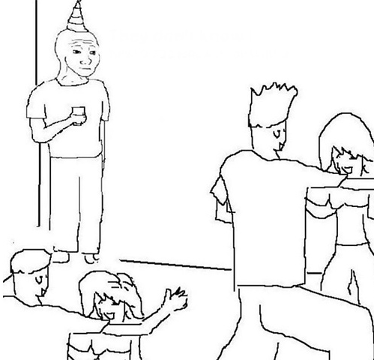
Based on your answers about the research party, write 3-4 topic sentences for your literature review that accounts for your above discoveries.
Use one of these structures to structure your topic sentences:
To highlight agreement: "Research seems to agree that [topic]..."
To highlight disagreement: "The evidence on [topic] is mixed...", with Author A arguing [X] while Author B argues [Y].
To highlight the gap: "While numerous authors support the claim that [topic], there is a lack of consensus regarding [X]. Even though research indicates X, the absence of Y affected group’s perspective calls the viability of the conclusion

